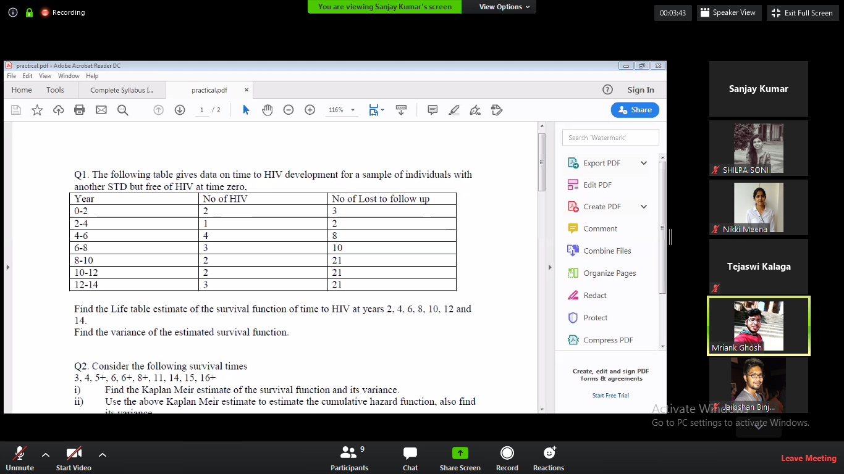

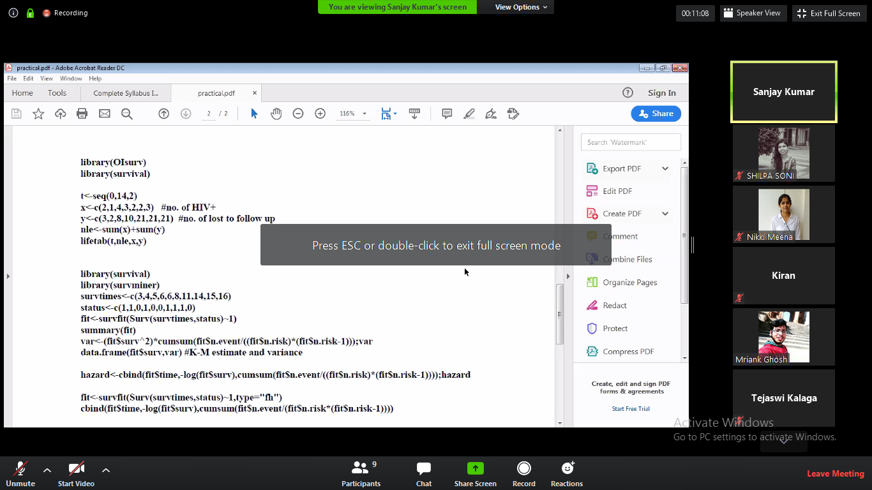







This



library(OIsurv)

library(survival)

t<-seq(0.14,2)

x<-c(2,1,4,3,2,2,9) #no. of HIV+

y<-c(3,2,8,10,21,21,21) #no. of lost to follow up

nle<-sum(x)+sum(y)

lifetab(t,nle,x,y)

library(survival)

library(survminer)

survtimes<-c(3,4,5,6,6,8,11,14,15,16)

status<-c(1,1,0,1,0,0,1,1,1,0)

fit<- survfit(Surv(survtimes,status)~1)

summary(fit)

var<-(fit$surv^2)\*cumsum(fit$n.event /((fit$n.risk)\*(fit$n.risk-1 )));var

data.frame(fit$surv,var) #K-M estimate and variance

hazard<-cbind( fit$time,-log(fit$surv),cumsum(fit$n.event /((fit$n.risk)\*(fit$n.risk -1))));hazard

fit<-survfit(Surv(survtimes,status)~1,type="fh")

cbind(fit$time,-log(fit$surv),cumsum(fit$n.event /(fit$n.risk\*(fit$n.risk -1))))